Invitation and information 2nd European Fullcontact Karate Cup. Selection Tournament WFKO World Championship

Invitation & Guidelines

Dear Presidents, Country Representatives, Branch Chiefs, National Coaches,
Dear Shihan, Sensei, Senpai, Dojo Leaders and Karateka
On behalf of The EFKO European Fullcontact Karate Organization, we are very honoured and proud to invite you to the:
“2nd European Fullcontact Karate Cup”
Selection Championship for
“1st World Fullcontact Karate Championship”
In Japan – Tokyo, May 2025

The “2nd European Fullcontact Karate Cup will take place on Saturday November 23rd and Sunday 24th in the city of Antwerp, Belgium.
The tournament will take place in the Arenahal, Arenplein 1, 2100 Antwerp/Deurne. The Antwerp Diamondcup, well known in Europe, is also held in this venue.
As the preparations of the Tournament are on-going and many volunteers are putting tremendous amounts of effort into the success of this event, we’re proud to announce the full support of the City of Antwerp. Thanks to our sponsors, arrangements have been made in 4-star hotel Mercure City South, making sure our participants can perform their best while competing for their title and place to get selected.
WFKO World Championship: As you know in May 2025 a united World championship for all Fullcontact Karate styles and organizations will be held. This World Championship will be held in Tokyo in the Ariake Gymnastic Center. The tournament in Antwerp, Belgium will be the official selection tournament to select European fighters for the WFKO World Championship. Our goal is to send the strongest European team to Japan.
Open and fair championship: This championship is open for all Fullcontact karate organizations and styles. We work under the guidance of the “World Fullcontact Karate Organization” (WFKO) and the “European Fullcontact Karate Organization” (EFKO). The championship will be equal and fair for all fighters. This tournament wants to connect people, organizations, styles and countries. The only way to make it a big success is to work together as one team for the benefits of Fullcontact Karate.
European Countries: The following countries are part of the European region and people from these countries are able to participate in this selection tournament: Andorra, Armenia, Austria, Azerbaijan, Belarus, Belgium, Bosnia and Herzegovina, Bulgaria, Croatia, Check Republic, Denmark, Estonia, Finland, France, Georgia, Germany, Great Britain, Greece, Hungary, Italy, Israel, Latvia, Lichtenstein, Lithuania, Moldavia, The Netherlands, Norway, Poland, Portugal, Romania, Servia, Slovakia, Spain, Sweden, Switzerland, Ukraine, Vatican City. Cyprus, Macedonia, Iceland, Ireland, Luxembourg, Malta, Moldova, Scotland, Serbia, Slovenia, Turkey. All other countries can join the selection tournament in their own respective regions.
Honoured guests: We are very proud to welcome the presence of the President of WFKO, Shihan Midori Kenji, the WFKO secretary Shihan Yasukazu Koi and three times WKO World Champion Shihan Tsukamoto Norichika. Also from Europe, we welcome the president from KWF Shihan Antonio Pinero, the president from IFK David Pickthall, the president of WKO Remigiusz Karpinski, the president of Ashihara Nicu Dascalu, Shihan Semmy Schilt, Sensei Jonathan Tineo and more.
We also expect to welcome many leaders, presidents and special guests from different Fullcontact Karate Organizations.
This document will provide more information on the 2nd EFKO Championship. As we’re nearing to the event itself, more information will be provided to you by e-mail and through our website www.efko.info. Registration for participants and officials will open officially on March 23rd, 2024. Please visit the Kumite technology site to register for participants, referees, coaches and officials. Payments have to be done on the EFKO website: www.efko.info.
We are certain that the family sentiment of all karateka combined with the “Never Give Up Spirit”, will guarantee a successful event, giving Fullcontact Karate the attention it deserves! We are very honoured to enjoy the finest competitors of Europe together with you! Friendships will be strengthened and unified through our Fullcontact karate. Together we are better, Osu!

EFKO board,
Shihan Koen Spitaels (Tournament chairman)
Organizing committee

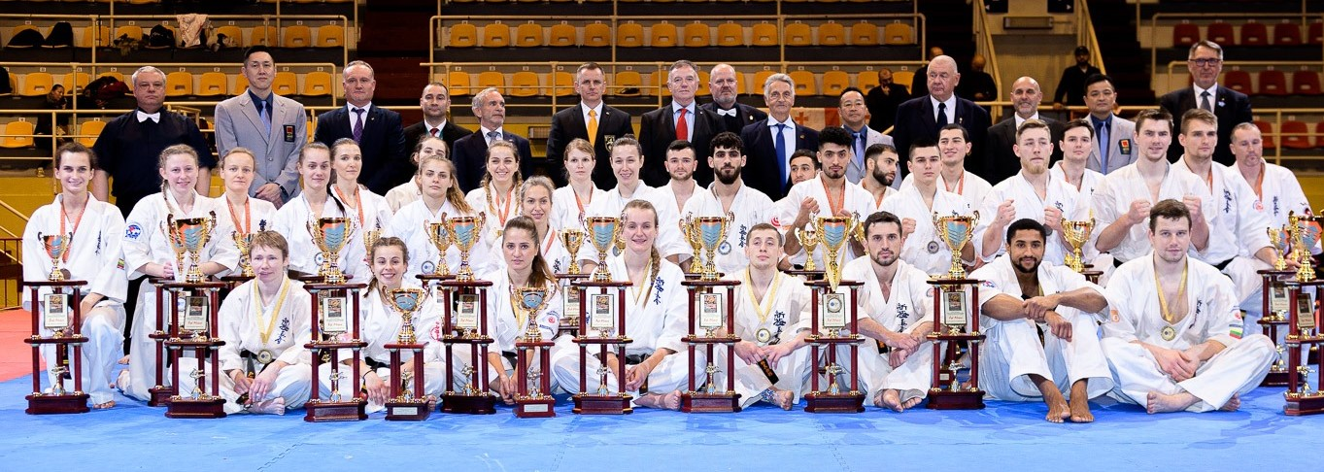

Official addresses
Event location | Official Hotel | Organisation
Arenahal | Mercure south city Antwerp | EFKO
Arenaplein 1 | Desguinlei 94 | Hemelakkers 1
B-2100 Deurne (Antwerp) | 2018 Antwerpen | B-2930 Brasschaat
info@efko.info | Info and registration online | info@efko.info

Tournament categories
Weight classes men |  | Weight classes woman
Super Light weight | -60 kg | Super Light weight | -50 kg
Light weight | -70 kg | Light weight | -54 kg
Middle weight | -80 kg | Middle weight | -59 kg
Heavy weight | -90 kg | Heavy weight | -65 kg
Super heavy weight | +90 kg | Super heavy weight | +65 kg

Protection
Protection men | Protection women
Groin protection | Breast protection (only the cup type is allowed)
Mouth protection (optional) | Shin protection
 | Mouth protection (optional)

Who can participate
Every fighter of 18 years and up, who is part of a dojo, group and/or organisation in a European country can participate. In the future we plan to organise a selection tournament in each European country, to make a united national team to participate in the EFKO selection tournament.
The EFKO selection tournament is a high-level tournament. So only fighters with extensive fighting experience and who have experience at fighting on an international level are allowed to participate, we’re asking you to make select your best fighters and we require a minimum grade of 4th kyu for participants.
Participants who will reach the first or second place in their category, automatically qualify for the WFKO world championship in Japan. Participants who reach the 3rd place will be a back-up fighter and will be qualified for the WFKO world championship in case of an injury with any of the other already qualified participants or when an additional spot is being made available to European Fighters.

Rules
All fights will be under the WFKO rules, tournament rules are available on the website and in the attachments to this letter.

Registration for fighters and officials
Registration for participants, referees, officials officially opens on March 15th 2024 and can be done by yourself on the Kumite Technology platform.
Deadline for national teams, officials, referees and others is October 5th, 2024. After this date no more applications or cancellations will be accepted. Registrations can only be accepted when all required documents and payments have been received and processed on time.
All participants are requested to present the following documents which are included in the attachments to this letter.
- A written medical certificate (English or Dutch), not older than 3 months.
- A written certificate of non-pregnancy for all female participants.
- A signed Participant state of health.

Weight and medical check
A weight and medical check will be performed on all participants. Please be aware that the weight check is only to verify the weight you registered during registration. The actual weight of the fighter at the time of the weight check has to match the weight used at registration. If your fighter is exceeding the weight limit of the category he or she registered for, we will cancel his or her registration. No excuses will be allowed.
A medical check on all participants will be performed by a doctor, be sure to bring your medical documents. Be advised that there will be a doping control test by the Belgium anti-doping committee.
More relevant details will be provided after registration. The only possible moment for everyone to go through the weight and medical check is on Friday November 22nd. There is no possibility for weighing on Saturday like in Diamondcup, so be sure you plan to be at the weight and medical check on Friday.

Trophies and presents
Every fighter who wins a first place will get a diamond, sponsored by the diamond factory of Antwerp. There will be trophies, medals and certificates for the first 3 competitors in each category. In addition, we have trophies for best technique and best spirit. All participants will get a nice a bag with souvenirs.

Draw
We will organize a fair and equal tournament for all participants. Fights in the first round between participants from the same country will be avoided as much as possible. The draw will be open and transparent for everyone on Friday November 22nd 20.30 hours.

Referee invitation
The referees for EFKO Selection competition are invited in two groups. All accepted referees must take part in the referee seminar before the competition. In total we need about 45 referees.
- The four partner organisations who have signed the EFKO cooperation agreement (EKO, KWF, IFK and Ashihara) will each appoint six experienced referees. Deadline is the 1st of June. Name and contact information must be sent to Michael Söderkvist (michael.soderkvist@jgy.se) and Koen Spitaels (info@nijiyama.be). We ask each of the organisations to select referees from different countries so that we have a good and fair team of referees.
- Referees from other organisations participating in the championship can apply and be chosen according to experience and level. Deadline is 1st of June. Name and contact information must be sent to Michael Söderkvist (michael.soderkvist@jgy.se) and Koen Spitaels (info@nijiyama.be). Decision on which of those referees will be selected, will be made not later than 31st of June.

Referee seminar
Referees are required to join a mandatory referee seminar, which will be held on November 22nd from 10.00 until 18.00 hours. Only referees selected by the referee committee are invited. If you do not attend this seminar, you can’t participate as a judge or referee. All registered referees and judges will get a detailed schedule and other relevant information. Referees will get an EFKO referee shirt and a nice present. They also have free entrance to the Sayonara party and lunches during the tournament.
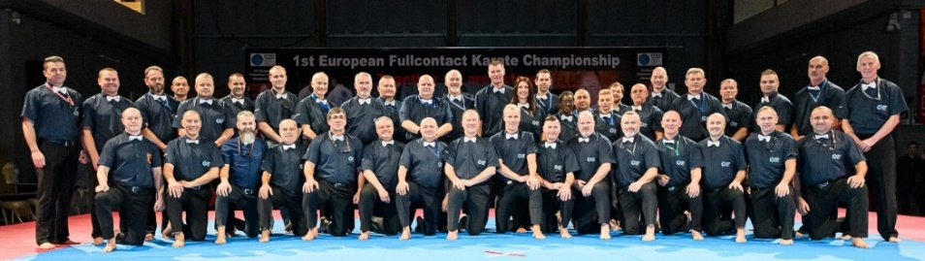

Coaches
An online meeting for coaches will be held in August or September as we want all coaches to be well informed on the rules and regulations of the tournament.
Coaches have a free entrance ticket for the tournament and free bus transportation from official tournament hotel to the venue. We allow 1 coach per 3 fighters. On both tournament days we will have a briefing for coaches in the sport hall before the start of the fights. Coaches are required to dress in track suits and they are required to behave in accordance with budo rules. The sayonara party is not free for coaches, so please order your sayonara tickets.
We will allow 2 coaches at the tatami. Both coaches can coach together but they can’t disturb the referees or fight. Both of them will get a ribbon to enter the tatami area and they have to return that when they leave the tatami area. An orderly tatami area is going to be very important for this tournament.

Travel and accommodation
Accommodation, flight tickets, meals and other costs are the sole responsibility for all attendees (including participants, referees and officials) unless otherwise agreed explicitly with the organisation.

Travel
The transportation between the hotel and the sports hall on tournament days, will be free for all participants, coaches, referees and officials.
For airport transportation from Brussels airport to the hotel you can use the Sabena shuttle bus. Price for that bus is € 10,- for a one way ticket and the bus stops 100 meters from the hotel. This bus connection is operated by the Belgian government, the organizing committee for this tournament is not responsible for this transport.
The participation fee will be € 95 for each participant. Included in this fee is entrance to the Sayonara party and tournament, anti-doping and a goody bag with presents.

Accommodation
The official tournament hotel is a 4-star Hotel, Mercure City South Hotel Antwerp, with all necessary facilities. In addition to the official tournament hotel, you can choose to book accommodation in two other hotels: Holiday Inn Express Antwerp or Mercure City Center Antwerp. If you want to ensure you have a hotel accommodation, make sure to book before October 5th 2024. After this date accommodation at one of the aforementioned hotels is not guaranteed.
Mercure City South Hotel Antwerp – Official Tournament Hotel
Mercure city south Antwerp Hotel is a smart 4-star hotel in Antwerp, conveniently located in the heart of the business district and just a ten minutes’ drive (3 km) from the historic city centre. Antwerp City Centre is easily accessible by a regular tram service which operates seven days a week from 6 AM to midnight. The tram stop is just outside the entrance to the hotel. Travel time to the city centre is approx. 10 minutes.
In a nutshell: free internet throughout the hotel, easily accessible by car and public transportation, private parking facilities (additional charges apply), fitness room, saunas, meeting rooms, party place and more!
Hotel reservations have to be done directly with the hotel. When contacting the hotel to make your reservation, you will receive a form from the hotel. Please return the filled in form to the hotel as well as the tournament organization. Deadline for hotel reservations is October 5th.
info@efko.infoAddress:
Desguinlei 94, 2018 Antwerp
Mercure City South Antwerp | Twin room  Double room  Single room  City tax | € 120 per room incl. breakfast  € 120 per room incl. breakfast  € 105 per room incl. breakfast  € 3 per person per night

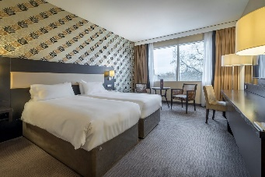
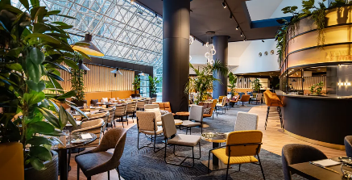
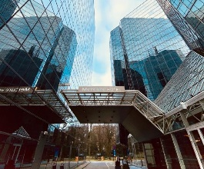

Holiday Inn Express Antwerp
Address:
Italielei 2A, Het Eilandje, 2000 Antwerpen
Holiday Inn Express Antwerp | Twin room  Double room  Single room  City tax | € 120 per room incl. breakfast  € 120 per room incl. breakfast  € 105 per room incl. breakfast  € 3 per person per night

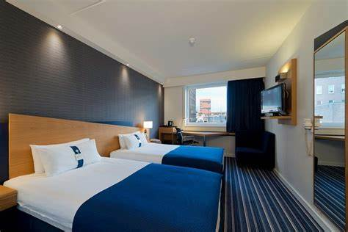
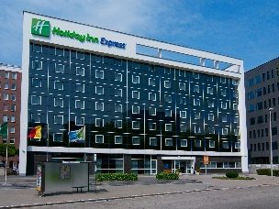
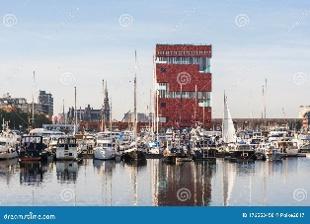

Mercure City Center Antwerp
Address:
Quinten Matsijslei 25, 2018 Antwerpen
Mercure City Center Antwerp | Twin room  Double room  Single room  City tax | € 155 per room incl. breakfast  € 155 per room incl. breakfast  € 145 per room incl. breakfast  € 3 per person per night

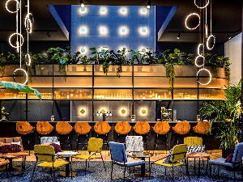
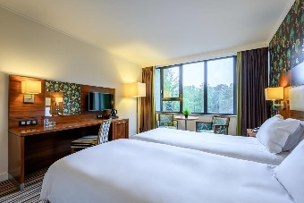
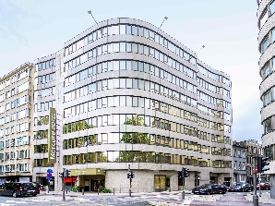

Entrance
Kids under 10 years will have free entrance. Visitors of 10 years and up will have to buy entrance tickets. Three types of regular entrance tickets are available:
Saturday November 23rd: € 30,-
Sunday November 24th: € 40,-
Combination tickets for two days: € 60,-

VIP Tickets
On Sunday you will have the possibility to book a ring side table. These tables serve VIP treatment. For more information, please contact Shihan Koen Spitaels: info@efko.info.

Tournament T-shirt
We will supply a very nice but limited official t-shirt from the EFKO Selection Tournament
Prize will be 30€ you can order them at our web shop.

Memorial Dogi
We will create a personalized memorial dogi specially for this EFKO Selection tournament. More info will follow later.

Payments
All fees (participation, sayonara party, entrance to the venue) can be paid in the webshop on our website www.efko.info. Please note that registrations for participation are only completed after completion of the payment. Deadline for payment of participation fees is October 5th 2024.

Cancellation policy:
The hotel must be been booked before 5th October 2024, otherwise we cannot guarantee that there will be place, so make your reservation in time please. Individual rooms can be canceled till 2 weeks from before, after that cancellation will not be possible anymore.

Schedule
At arrival and check-in, detailed schedules are available. For specific questions, please send an e-mail to: info@efko.info.

Contact persons
Twan Smolders Sensei
Email: info@efko.info
Koen Spitaels Shihan
Email: info@efko.info

We wish everyone a great tournament and a nice stay in the city of Diamonds.
OSU!

